

**Project Report**

**Analyze the difficulty level of a particular course using classification techniques**

**Course Title: Machine Learning Foundation**

**Course Code: INT247**

Submitted By:

Srikakolla Mohith

Reg. No: 11707426

Section: KM028

Roll. No: 22

Submitted To:

**Usha Mittal**

**Introduction:**

* This is the project I have been assigned to in INT247.
* Name: Analyze the difficulty level of a particular course using classification techniques.
* Dataset : Bachelor of Technology (Automobile Engineering Engineering).

**1.Collection of Database/necessary requirements for project:**

* Database of all the students necessary for the project is given in an csv file with every other detail.
* It will be attached with this report in the zip folder.

**2.Implementation of Code:**

* Data Pre-processing
* Choosing appropriate model
* Training(Retraining for optimization)
* Evaluating Accuracy with confusion matrix
* Hyper parameters tuning
* Prediction on new data
* Explained the used python library/necessity/ purpose in ipynb file.
* Executable Code should be self-explanatory using comment lines in ipynb file.
* Explanation of each modules/ files/used in project in ipynb file.

**3. Innovation/newness made in project:**

* Self-created Video is attached in the zip folder.

**4. Result Visualization/ Graphs:**

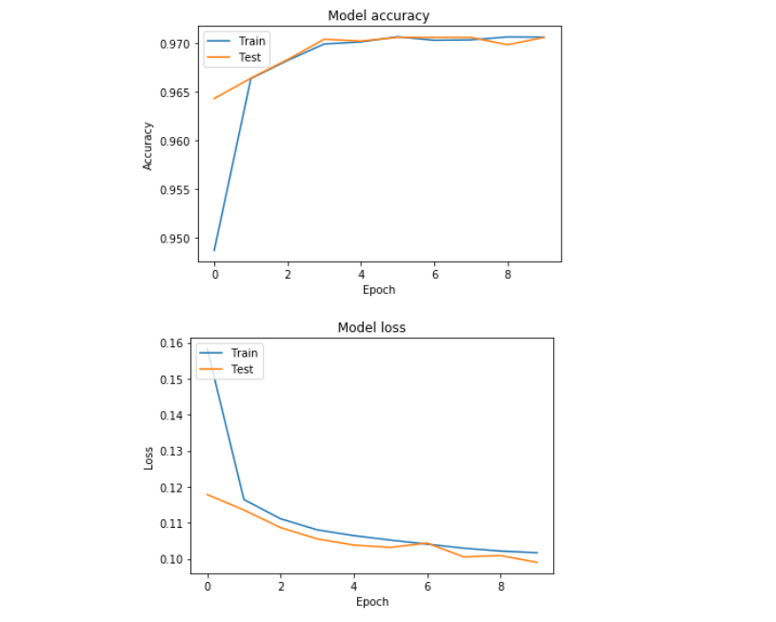

**5. GitHub commits/repository:**

* Link for GitHub: <https://github.com/MohithSrikakolla/ML-project1>